Experiment No. 3

Aim :- To write a program using Lex to count the number of characters, words, spaces and lines in a given input file.

Pre-requisite :- Knowledge of Lex and regular expression to recognize word, end of line, etc.

ASSUMPTIONS :-

1. The string length is of maximum 50 characters
2. Two words separated by only one white space of tab char.

ALGORITHM:-

1. Declare the necessary variables.
2. Define, regular definition in lex to recognize word, end of line, spaces

word [^ \t\n]+

eol [\n]

blank [ ]

1. Define actions with each lexeme.

{blank} bc++;

{word} {wc++;cc+=yyleng;}

{eol} {cc++;lc++;}

. {ECHO;cc++;}

Inside main function write the code to open the file which name has accepted by main function arguments (int argc, char* argv[]) and associate it with laxer input pointer(**yyin).**

CODE:-

%{

#include<stdio.h>

int cc=0,bc=0,wc=0,lc=0;

%}

%%

[^ \t\n]+ { wc++;

cc=cc+yyleng;

}

\n lc++;

" " bc++;

\t bc=bc+5;

%%

main(int argc, char *argv[])

{

if (argc!=2) {

printf("\nusage:./a.out filename\n");

return 0;

}

yyin=fopen(argv[1],"r");

yylex();

printf("\n no. of lines are %d\n",lc);

printf("\n no. of words are %d\n",wc);

printf("\n no. of blanks are %d\n",bc);

printf("\n no. of character are %d\n",cc);

}

int yywrap()

{

return 1;

}

OUTPUT:-

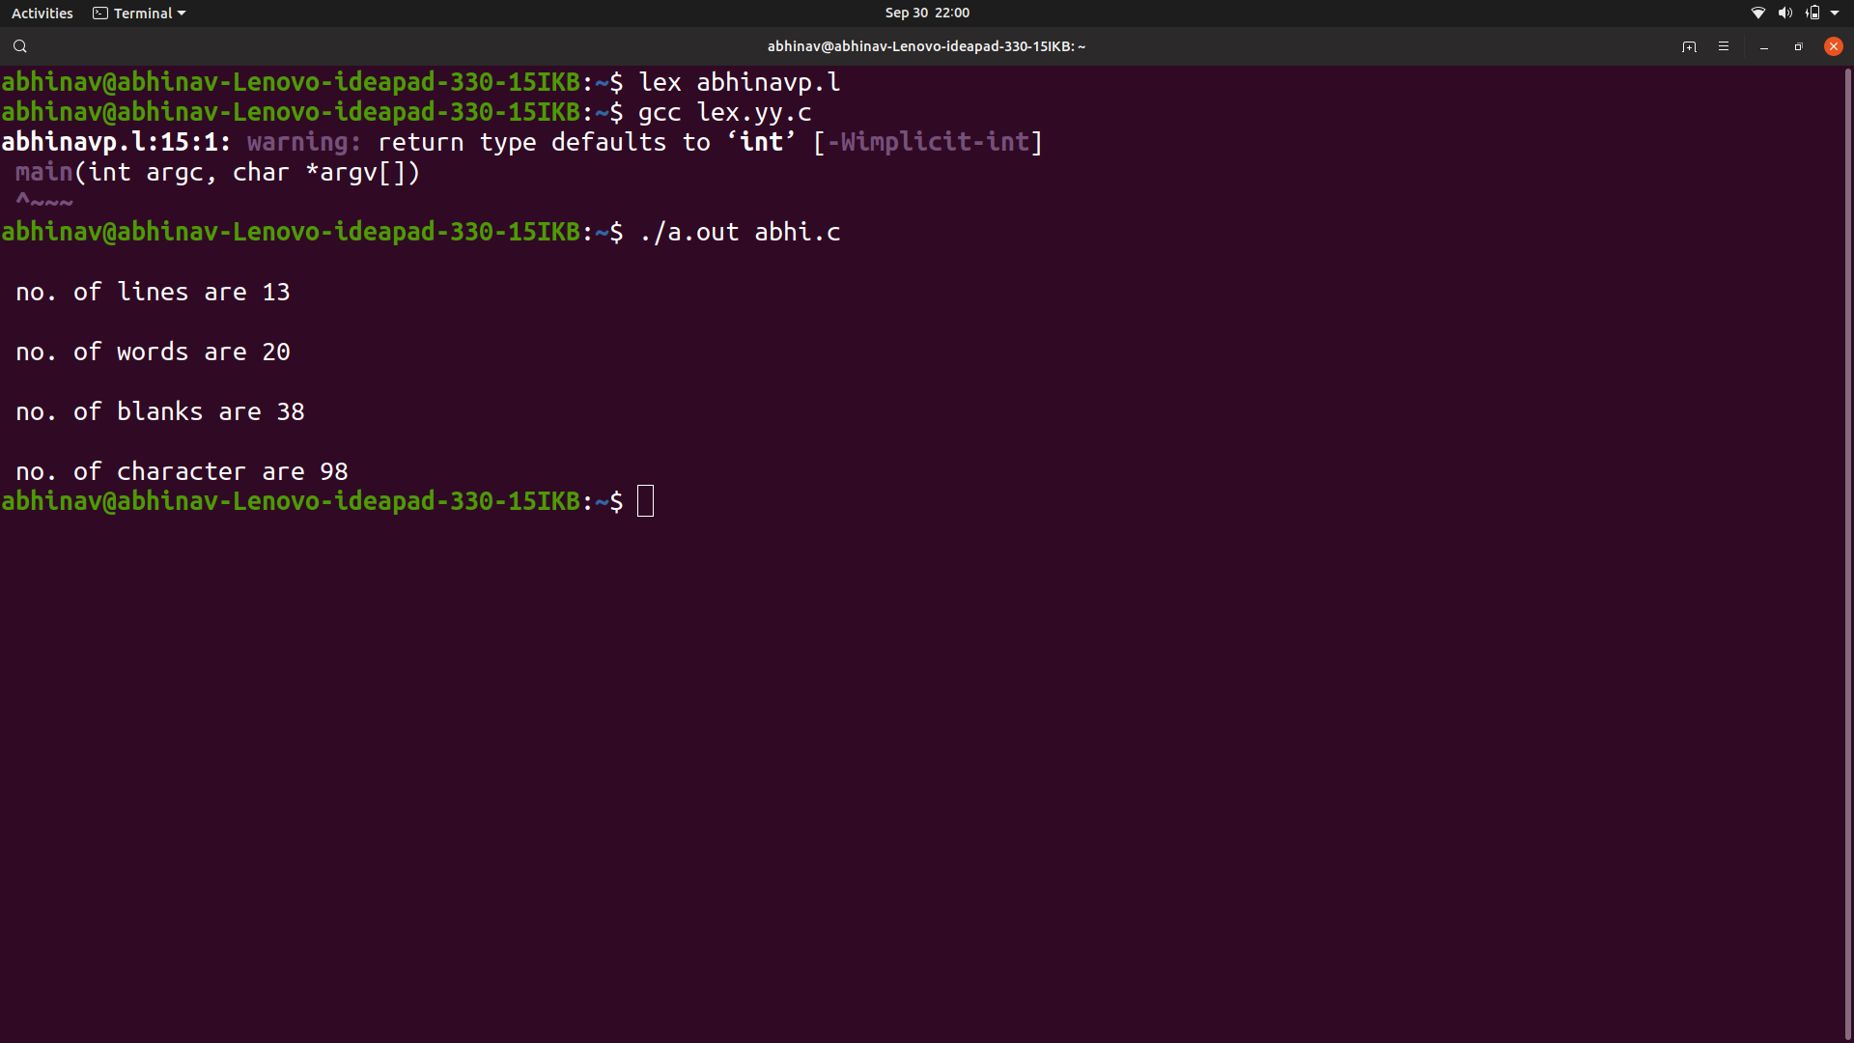

RESULT :- Above program using Lex to count the number of characters, words, spaces and lines in a given input file has been executed Sucessfully.